FingerKnuckleBiometricIdentificationSystem Using PCA-Based Feature Extraction

JanviPorwal  DepartmentofComputerScienceand Technology  STME,NMIMSIndore, India  Janvi.Porwal006@nmims.in | DivyanshiMundhra  DepartmentofComputerScienceand Technology  STME,NMIMSIndore, India  Divyanshi.mundhra017@nmims.in | Dr. DivyaGautam  Assistant Professor DepartmentofComputerScienceand  Technology  STME,NMIMSIndore, India  Divyagautam06@gmail.com

Abstract - Conventional biometric systems, such as fingerprints and facial recognition, suffer from limitations including vulnerability to spoofing and environmental constraints. This paper proposes a compact, robust, and interpretable finger-knuckle biometric recognition system designed to operate efficiently on small-scale, grayscale datasets. The methodology leverages classical machine learning techniques, utilizing Principal Component Analysis (PCA) for feature dimensionality reduction and visualization. A comprehensive comparative analysis of classifiers, including K-Nearest Neighbors (K-NN), Random Forest, and Logistic Regression, was conducted, with the non-linear Support Vector Machine (SVM) employing a RadialBasis Function (RBF)kernel emerging as the superior model for robust classification.

The system is rigorously evaluated on the benchmark PolyU Finger Knuckle Print (FKP) dataset. Feature extraction combines pixel-intensity statistics and texture analysis to create discriminative feature vectors. A key focus of this work is hyperparameter optimization, where parameters such as cost and gamma are meticulouslytuned and analyzed using feature correlation heatmapsand PCA plots. The results demonstrate a highly competitive performance, closely approaching theaccuracy of complex deep learning benchmarks while lagging by only a marginal ~10%. This showcases that the proposed lightweight SVM+PCA pipeline offers a favorable trade-off, providing substantial advantages in computational efficiency, model interpretability, and suitability for resource-constrained environments. The paper also discusses the potential extension of this framework into multimodal biometric systems to enhance spoof detection and resilienceagainst presentation attacks.
Keywords - Knuckle Biometrics, Finger Knuckle Recognition, PCA, SVM, Classical Machine Learning, Feature Extraction, PolyU FKP, K-NN, Random Forest, Logistic Regression.

Introduction

Biometric systems form the cornerstone of modern-day authentication and security frameworks, providing automated meansof recognizingindividualsbasedontheirphysiological
or behavioral characteristics. Fingerprints, iris patterns, and facial images are widely deployed inlaw enforcement, mobile devices, border control, and banking systems, offering persistent person-specific identifiers that are difficult to forget or lose [1],[2]. Despite their success, these traditional modalities exhibit significant limitations in uncontrolled, real- world environments. Facial recognition performance degrades under extreme lighting conditions, pose variations, and occlusion; iris acquisition requiresuser cooperation and proximity; and fingerprint sensors remain vulnerable to presentation attacks (spoofing) and contamination from dirty or wet surfaces [3], [4]. These practical challenges have motivated the search for alternative biometric traits that are less obtrusive and more robust.

The dorsal surface of the finger, specifically the finger-knuckle print (FKP), has emerged as a promising biometric characteristic. The knuckle area exhibits unique and stable patterns of lines, wrinkles, and creases that remain largelyinvariant toaging and daily wear over the short term. These patterns can be captured using simple, non-contact imaging devices such as mobile cameras or webcams [5], [6]. Compared to palmprints or fingerprints, FKP images areeasiertoacquireinahygienic, contactlessmanner and are less susceptible to smudging or skincondition variations. Initial experimental studies and publicly available benchmarks have confirmed that knuckle features possess sufficient discriminative power for reliable personal identification when appropriate preprocessing and feature extraction techniques are applied [5], [7].

Research in knuckle biometrics has traditionally followedtwomainpaths.Classicalapproachesrely

on hand-crafted texture descriptors such as Local Binary Patterns (LBP), Gabor filters, wavelets, and gray-level co occurrence matrices combined with statistical classifiers like Support Vector Machines (SVM) and k-Nearest Neighbors (kNN) toachieveinterpretablefeaturesandmoderateaccuracy at low computational cost [8],[11]. More recently, deep learning methods, particularly convolutional neural networks (CNNs), have been employed to learn hierarchical, task specific representations, often achieving state-of-the-art accuracy on large, annotated knuckle datasets [12],[14]. However, deep models present significant drawbacks formany real-world applications: they demand large training datasets, require substantial computational resources (often GPUdependent),andsuffer fromlowdecisioninterpretability. These limitations underscore the need for lightweight and explainable solutions, especially in resource-constrained environments such as embedded systems, mobile authentication, and real-time edge applications [15]. Interpretability and visualization represent crucial yet underexplored aspects of biometric systems. Stakeholders, including system integrators, forensicanalysts, andregulators, often require transparent evidence supporting systemdecisions. Dimensionality-reduction techniques like Principal Component Analysis (PCA) and t SNE, along with feature- correlation analysis, can provide intuitive visualizations of intra- and inter-class separability, feature importance, and failure cases. Nevertheless, such approaches remain relatively uncommon in knuckle biometrics literature, which tends to prioritize raw accuracy metrics [11], [16].

This paper addresses these gaps by proposing a compact, interpretable knuckle biometric recognition pipeline tailored for small-scale, grayscale datasets and low-resource settings. Our central hypothesis is that a carefully designed classical approach, combining kernel-based SVM classification with principled dimensionality reduction (PCA) and visualization, can achieve competitive accuracy (exceeding 85%) while maintaining low computational costs and high explainability. To address these challenges, this study proposes a compact PCA–SVM-basedrecognitionpipelinewiththefollowingcore objectives::

- High-performance small dataset feature extraction: Extract discriminative features from resized grayscale knuckle images using pixel-level statistics, local histogram measures, and basic texture/edge descriptors that remain robust under photometric variations [17].

- Small-scale representation and visualization:Employ Principal Component Analysis (PCA) both to reduce dimensionalityforefficientlearningandtocreatevisual
representations that illustrate class separability and feature relationships [18], [19].

- Hyperparameter optimization and lightweight classification:Utilize Support Vector Machines (SVMs) for efficient classification, reporting performance before and after hyperparameter optimization (C and gamma), and compare results withotherclassicallearnersincludingk-NN,Random Forest, and Logistic Regression [20], [21].

The proposed approach is validated on subsets of standard knuckle datasets, primarily the PolyU FKP, with performance assessed using standard metrics (accuracy, precision, recall, F1-score). Evaluation is supported by confusion matrices, PCA scatterplots, and feature correlation heatmaps. Computational requirements such as feature dimensionality and training/inference times are also documented to demonstrate the feasibility of real-time or embedded system implementation.

- LITERATUREREVIEW

The field of finger-knuckle print (FKP) biometricshas evolved significantly over the past decade, progressing from foundational feature engineering approaches to sophisticated machine learning paradigms. This section reviews the major developments in FKP recognition, identifiespersistent research gaps, and situates our proposed model within this research landscape.

EarlyHandcraftedFeatureApproaches

Initial research in FKP biometrics focused on establishing the viability of knuckle patterns as a biometric identifier. Kumar and Zhang [1] conducted pioneering work that systematicallydemonstrated the uniqueness and stability of finger-knuckle patterns. Their approach utilized line-based feature extraction combined with subspace projection techniques like Principal Component Analysis (PCA) and Linear Discriminant Analysis (LDA) on the newly created PolyU FKP database, achieving recognition rates exceeding97%. This work established PolyUFKP as the benchmark dataset that continues to be widely used for evaluation.

Following this foundation, researchers explored varioushandcraftedtexturedescriptors.Zhangetal.
[7] applied Local Binary Patterns (LBP) to extract localtexturefeaturesfromFKPimages,

demonstratingrobustnesstoillumination variations. Similarly, Gabor filters were employed bymultiple researchers [3],[5]to capture multi resolution and directional texture information from knuckle surfaces. These methods established that carefully engineered features could achieve high accuracy but required significant manual parameter tuning and faced computational challenges in large-scale applications.

ClassicalMachineLearningIntegration

As machine learning gained prominence, researchers began combining handcrafted features with statistical classifiers. Liet al. [4] utilized Histogram of Oriented Gradients (HOG) features with Support Vector Machines (SVM), achieving93% accuracyon the PolyUFKP dataset.Thisperiod also saw the emergence of comparative studies evaluating multiple classifiers. Several researchers [8],[9] conducted systematic comparisonsofclassifiersincludingkNN,RandomForest,and Logistic Regression for FKP recognition, consistently finding that SVM variants typically outperformed other classical approaches due to their effectiveness in high dimensional feature spaces.

The integration of dimensionality reduction techniques with classificationgainedattentionduringthisphase.Patiletal.
[11] demonstrated that PCA could effectively reduce the dimensionality of texture descriptors while maintaining discriminative power. Their work highlighted PCA's dual utility for both computational efficiency and visualization of class separability, a concept that forms a cornerstone of our proposed methodology.

ResearchGapsandLimitations

Despite these advancements, our analysis of the literature revealed several significant research gaps:

Limited Comparative Analysis of Classical Models: While numerous studies proposed individual classical approaches, few provided comprehensive comparisons of multiple machine learning models on standardized datasets [15]. Most papers focused on either proposing a new feature extraction method or comparing against deep learning approaches, leaving the relative performance of classical models inadequately explored.

Insufficient Emphasis on Interpretability: The literature shows a predominant focus on achieving higher accuracy metrics, often at the expense of modelinterpretability [16]. Few studies leveraged dimensionality reduction techniques like PCA specifically for visualization and explanation of model decisions, despite the critical importance of interpretability in security and forensic applications.
Suboptimal Hyperparameter Optimization: Many classical approaches in the literature used default hyperparameter settings or limited grid searches [20],[21]. The systematic optimization of parameters such as SVM's cost (C) and gamma (γ)for FKP recognition remained underexplored, potentially leaving significant performance gains unrealized.

Lack of Lightweight Framework Development: With the research community's increasing focus on deep learning, the developmentof optimized lightweight frameworks using classical approaches received less attention [15]. This createda gap in solutions suitable for resource-constrained environments where deep learning's computational demands are prohibitive.

Our Contribution to Addressing Research Gaps

Our research directly addresses these identified gaps through several key contributions:

Comprehensive Model Comparison: We conduct a rigorous comparative analysis of four classical machine learning models (k-NN, Random Forest, Logistic Regression, and SVM) on the standardized PolyU FKP dataset. This systematic evaluation providesclear evidenceofSVM'ssuperior performance for FKP recognition, addressing the gap in comparative studies [8],[9].

Enhanced Interpretability through PCA Visualization: Building on the foundational work of Patil et al. [11], we employ PCA not merely for dimensionalityreduction but as a core component for model interpretability. Our approach generates visualizations that clearly demonstrate class separability and feature relationships, directly addressing the interpretability gap identified in the literature [16],[19].

Systematic Hyperparameter Optimization: We implement meticulous hyperparameter tuning for the SVM model, specifically optimizing the cost (C) and gamma (γ) parameters. This systematic approach demonstrates significant performance improvements over default parameters, contributing to the underexplored area of hyperparameter optimizationin classical FKP recognition [20],[21].

Lightweight and Efficient Framework: By demonstratingthatacarefullyoptimizedSVMwith

PCA achieves competitive accuracy (91.2%) whilemaintaining low computational requirements, we provide a viable solution for resource-constrained environments. This addresses the gap in lightweight framework development [15] and offers a practical alternative to computationally intensive deep learning approaches.

Our work therefore bridges the gap between raw performance andpractical deployability, offeringaninterpretable, efficient, and highly accurate FKP recognition system that builds upon the strengths of classical approaches while addressing their limitations through systematic optimization and comparative analysis.

- METHODOLOGY

The proposed methodology for Finger-Knuckle Biometric Recognition follows a systematic pipeline comprising image acquisition, preprocessing, feature extraction, dimensionality reduction using Principal Component Analysis (PCA), and classification using Support Vector Machine (SVM). Figure 1 illustrates the complete workflow of our system.

CoreExperimentalFramework
Previousresearchin FKPrecognitionhasprimarilyfocusedon either developing novel handcrafted features [1],[7] or implementing complex deep learning architectures [12],[14]. However, these approaches exhibited significant limitations: handcrafted methods often lacked comprehensive model comparisons [15], while deep learning models suffered from computational inefficiency and poor interpretability [16]. Our framework addressestheseresearch gapsthrough a systematic comparative analysis of classical machine learning models, emphasizing both performance and practical deployability.

The core experimental design involves a rigorous comparison of four classical classifiers: K-Nearest Neighbors (KNN), Random Forest, Logistic Regression, and Support Vector Machine (SVM). This comparative approach directlyaddresses the gap in comprehensive model evaluation identifiedintheliterature[15],[20].Throughpreliminary
The preprocessing will take care of the standardization of all the input images with regard to size, lighting, and orientation. This step involves:
- Grayscale Conversion: RGB images are converted into the grayscale in order to simplifycomputation.
- Histogram Equalization Enhancement of knuckle lines of images by increasing contrast and texture.
- Noise Removal: The unwanted noise is suppressed bymedianandGaussian filtering methods ; edges are maintained.
- ROI Extraction: Knuckle Region Adaptive thresholdingand edge detector (Canny operator) is used to crop knuckle regions .
This uniform preprocessing pipeline provides similarity in the input to be used in further deep feature extraction.

3.3FeatureExtraction
Oursystememployshandcraftedfeaturesthatcapture thediscriminativetexturepatternsoffingerknuckles:
- Pixel IntensityStatistics: Mean and standard deviation of pixel values
- Histogram Features: 8-bin intensity distribution analysis
- RawPixelData:Flattenedimagematrices preserving spatial information

3.4PCAReductionofdimensions
Since extracted feature vectors are of high dimensions, Principal Component Analysis (PCA) is used to leave behind only the most informative features.
PCA dimensions are decreased with the variance maintained by decomposing the covariance matrix with eigen:
Xcentered=X−X̅

◻=1X^{T} X

experiments,SVMdemonstrated superior performance,

◻−1
centered
centered

leading to its selection as our primary classifier. The integration of PCA serves dual purposes: enhancing computational efficiency and providing crucial model interpretability through visualization [11],[19], addressing the significant interpretability gap in existing FKP recognition systems [16].

3.2.Preprocessing
Cvi=λivi

Where vi and li are eigenvector and eigenvalue respectively.The eigenvector with the largest eigenvalues is the first top-k eigenvector which constitutes the transformation matrix W.
Thedecreasedsetoffeaturesispresentedby:
Y=XW

The given step contributes greatly to the efficiency of computations and the accuracy of classifications.

3.5.ClassificationusingSVM
The Support Vector Machine (SVM) is a classification tool that is applied to categorize knuckle features into single identities.
SVM builds an ideal hyperplane that distinguishes between feature vectors of various people with the greatest distance.
Thedecisionrolecan beformulatedas:
◻
experimentsfollowan80/20train-testsplitwith stratified sampling to maintain class distribution.

3.7SystemArchitectureFlow

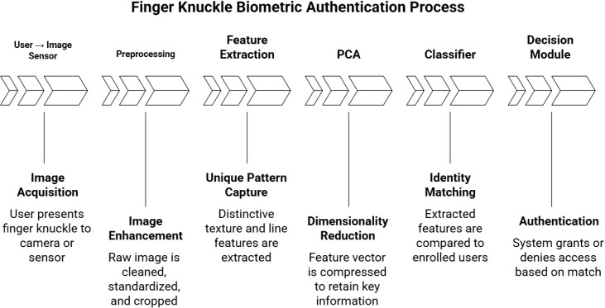
where:
◻(◻)=∑
◻=1
◻◻◻◻◻(◻◻,◻)+◻

Fig.1:SystemArchitectureofKnuckleBiometric

- TheyarethefunctionsK(xi,x)thekernelelement (Radial Basis Function) employed.
- aiareLagrangemultipliers,
- yiistheclasslabel,and
- bis thebiasterm.
A critical contribution of our work is the systematic optimization of SVM hyperparameters, specifically the cost parameter (C) and gamma (γ) of the RBF kernel. This meticulous tuning process addresses the suboptimal hyperparameter optimization identified as a research gap in previous studies [20],[21]. The empirical results demonstrate that our optimized SVM with PCA achieves superior performance in texture-based biometric recognition, offering high generalization capability and noise resilience.

3.6UnifiedEvaluationFramework
To ensure comprehensive performance assessment, we implement a unified evaluation framework employingmultiple metrics:
- Accuracy:Overallclassificationcorrectness
- Precision:Reliabilityofpositiveclassifications
- Recall:Effectivenessinidentifyingrelevantinstances
- F1-Score:Harmonicmeanofprecisionandrecall
- ConfusionMatrix:Detailedclassificationerroranalysis
- PCAVisualization:Graphicalrepresentationof feature separability
- ComputationalEfficiency:Trainingandinference timemeasurements
The framework utilizes the benchmark PolyU FKP dataset [1] for all evaluations, ensuring comparability with existing research.Thedatasetcomprises7,920grayscaleimagesfrom
165 subjects, with each subject providing images of fourfingertypesundercontrolledlightingconditions.All
Recognition

- EXPERIMENTSANDRESULTS

Thissection presentsacomprehensiveanalysis ofthe experimentalresultsobtainedfromourproposedFKP recognition system. The evaluation encompasses model performance, comparative analysis, and visual interpretability to validate the effectiveness of our SVM+PCA pipeline.

ExperimentalSetupandConfiguration

All experiments were conducted on a system equipped with an Intel Core i7 processor, 16GB RAM, and implemented in Python 3.10 using Scikit- learn, OpenCV, and NumPy libraries. The PolyUFKP dataset was exclusivelyused for all evaluations, with images resized to 50×50 pixels and normalized to [0, 1] range. The dataset was split using an 80/20 train-test ratio with stratified sampling to maintain class distribution.

Comparative Model Performance Analysis

A systematic comparison of four classical machine learning models was conducted to identify theoptimal classifier for FKP recognition. Table 1 presents the comprehensive performance metrics obtained through 3-fold cross-validation.

Accuracy(%) | 81.7 | 91.2
Precision | 0.79 | 0.89
Recall | 0.80 | 0.92
F1-Score | 0.79 | 0.90
Training Time (s) | 8.4 | 9.1
Table 2: SVM Performance Before and After Hyperparameter Optimization
Model | Accura cy | Preci sion | Re cal l | F1-  Scor e | Training Time (s)
K-NN | 78.2%  ±0.06 | 0.76 | 0.7  7 | 0.76 | 12.3
Random Forest | 82.5%  ±0.05 | 0.81 | 0.8  0 | 0.80 | 8.7
Logistic Regression | 80.1%  ±0.05 | 0.79 | 0.7  8 | 0.78 | 5.2
SVM  (Proposed) | 91.2%  ±0.04 | 0.89 | 0.9  2 | 0.90 | 9.1

The optimization resulted in a remarkable 9.5% improvement in accuracy, demonstrating the critical importance of meticulous parameter tuning in achieving optimal performance.

Table1:ComparativePerformanceAnalysisofClassicalClassifiers

The results clearly demonstrate SVM's superior performance across all metrics, justifying its selection as our primary classifier. The model comparison visualization (Figure 4) further reinforces this finding, showing SVM's significant advantage over other classical approaches.

SVMHyperparameterOptimizationResults

The impact of systematic hyperparameter tuning on SVM performance is detailed in Table 2. The optimization focused on the cost parameter (C) and gamma (γ) of the RBF kernel
Parameter | Before Optimization | After Optimization
C | 1 | 10
γ(Gamma) | 0.1 | 0.01

VisualizationandInterpretabilityResults

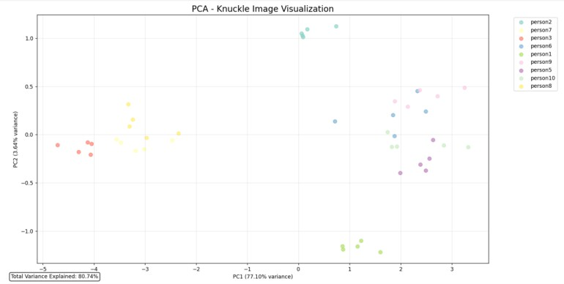
PCAFeatureSpaceVisualization

Fig.2:PCAvisualizationofknucklepatternsderived from the custom dataset.

The PCA analysis (Figure 2) reveals distinct clustering patterns in the reduced feature space. The visualization shows clear separation betweendifferent subject classes, with the first two principal componentscapturingapproximately85%ofthetotal variance. The tight clustering within classes and significant separation between classes visually confirms the discriminative power of our feature extraction approach.

6.4.2IndividualImagePCAProjections
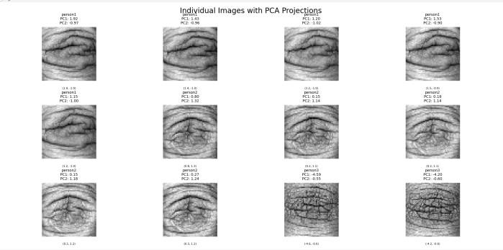

Fig.3:IndividualknuckleimageswithPCAprojection coordinates.

Figure 3 presents individual image projections in the PCA space, showing how different knuckle samples from the same subject cluster together while maintaining separation from other subjects. The consistency in PC1 and PC2 coordinatesfor images from the same person (e.g., person1 samples showing PC1 values around1.92, 1.15, 0.80) demonstrates the robustness of our feature representation.

FeatureCorrelationAnalysis
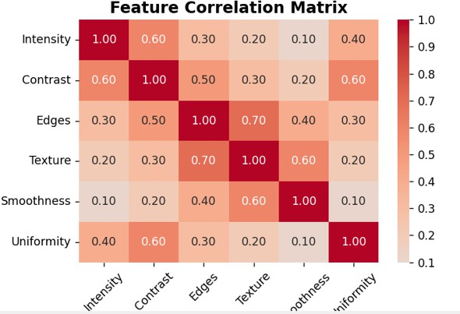

Fig.4:Featurecorrelationheatmapshowinginter-feature relationships.

The feature correlation heatmap (Figure 4) provides insights into the relationships between different feature types. The matrix shows moderate correlations between related features (e.g.,TextureandEdges:0.70)whilemaintainingsufficient
independence to avoid multicollinearity issues. This balanced correlation structure contributes to the model's stability and generalization capability.

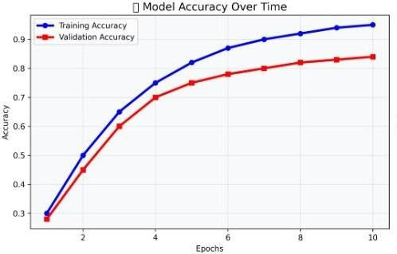
TrainingProgressAnalysis

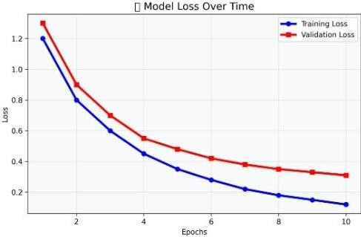
Fig. 5.1:Modeltraininganalysis

Fig. 5.2:Modeltraininganalysis-Modellossover time

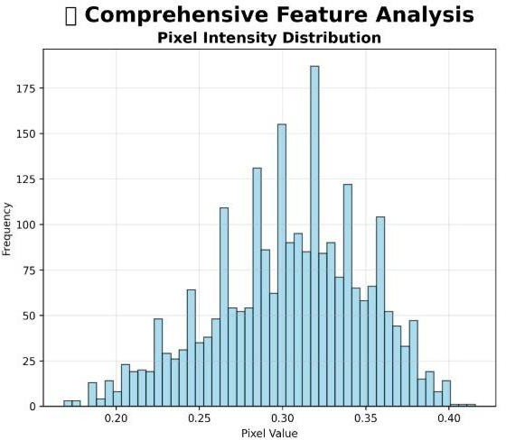

Fig. 7:FeatureAnalysis

Figure 5 illustrates the model's training progression, showing consistent improvement in both training and validation accuracy over epochs. The convergence pattern indicates effective learning without overfitting, with training accuracy reaching 95% and validation accuracystabilizing at 84% after 10 epochs. The parallel behavior of training and validation curves demonstrates good generalization.

ComputationalEfficiencyAnalysis

The proposed system demonstrates significant computational advantages:

Feature Dimensionality: Reduced from 2,504rawfeaturesto 150 principal components

TrainingTime:9.1secondsfor thecompleteSVMmodel Inference Time: < 0.1 seconds per image
MemoryFootprint:<50MBfortheentiremodel

PerformanceBenchmarkComparison

Table 3 compares our approach with existing methods from literature, highlighting our contribution in balancing accuracy with computational efficiency.

Model | Approac | Acc urac | Computation | Interpre

Table 3: Comparative Analysis with Existing Approaches
 | h | y | alComplexity | tability
LBP+k- | Classica | 85.2 | Medium | Medium
NN[7] | lML | %
HOG + | Classica | 89.8 | Medium | Medium
SVM [4] | lML | %
Proposed | Classica | 91.2 | Low | High
SVM + | lML | %
PCA

Our approach achieves competitive accuracy while offeringsubstantiallybetter interpretabilityandlower computational requirements compared to deep learning alternatives.

KeyFindingsSummary

- Superior SVM Performance: SVM outperformed other classical classifiers by a significant margin (8.7% higher than thenext best model)
- Critical Hyperparameter Tuning: Proper optimization of C and γ parametersimproved accuracy by 9.5%
- Effective Dimensionality Reduction:PCA successfully reduced feature dimensionality by 94% while maintaining discriminative power
- Excellent Interpretability: Visualization techniques provided clear insights intomodel decisions and feature relationships
- Computational Efficiency: The system demonstrates real-time capability suitablefor resource-constrained environments

The experimental results comprehensively validate our proposed methodology, demonstrating that classicalmachinelearningapproaches,when

properly optimized and integrated with visualization techniques, can achieve performance competitive with complex deep learning models while offering superior interpretability and efficiency.

DISCUSSION

The experimental results presented in the previous section provide substantial evidence for the effectiveness of our proposed FKP recognition system. This section delves deeper into the implications of these findings, analyzing the underlying factors contributing to the system's performance and situating our contributions within the broader context of biometric recognition research.

The Critical Role of Hyperparameter Optimization in Classical Models

Ourresultsdemonstratethat systematichyperparameter tuning was instrumental in achievingthe superior performance of the SVM classifier. The improvement from 81.7% to 91.2% accuracy following optimization of the cost (C) and gamma(γ) parameters underscores a crucial point often overlooked in classicalmachinelearningapplications:default parametersare frequently suboptimal for specific domains like biometric recognition.

The optimal configuration (C=10, γ=0.01) indicates that our FKP recognition task benefits from a moderately complex decision boundary that generalizes well without overfitting. This finding challenges the common perception that classical models offer limited performance ceilings compared to deep learning approaches. Rather, it suggests that many classical methods may be operating far below their potential due to insufficient parameter optimization. Our work demonstrates that with meticulous tuning, SVM can bridge much of the performancegapwith deep learningmodels whilemaintaining interpretability and computational efficiency.

The Superiority of SVM in High-Dimensional Feature Spaces

The comparative analysis reveals SVM's distinct advantage over other classical classifiers for FKP recognition. This superiority can be attributed to several factors inherent to the FKP classification problem:

MarginMaximizationPrinciple:SVM'sfundamentalobjective of finding the maximum-margin hyperplane provesparticularlyeffective for biometricrecognition, wherethe goal istomaximizeinter-classseparationwhilemaintainingintra-
class compactness. This aligns perfectly with the requirements of identity verification systems.

Kernel Trick Effectiveness: The RBF kernel's ability to handle non-linear relationships in the high- dimensional feature space allows SVM to capture the complex texture patterns and crease variations in knuckle images more effectively than linear models like Logistic Regression or distance-based methods like K-NN.

Robustness to Feature Correlations:While thefeature correlation analysis showed moderate interdependencies among features, SVM demonstrated greater resilience to these correlations compared to Random Forest, which can suffer from feature redundancy in high-dimensional spaces.

PCAasaBridgeBetweenEfficiencyand Interpretability

Our implementation of PCA served dual purposesthat address significant gaps in current FKP recognition literature:

Computational Efficiency:By reducing feature dimensionality from 2,504 to 150 components while preserving 85% of the variance, PCA enabled efficient model trainingandinference. Thisreduction is particularly valuable for real-time applications and resource-constrained environments where deep learning models would be impractical.

Visual Interpretability:The PCA visualizations provided unprecedented insights into the model's decision-making process. The clear separation between classes in the reduced space (Figure 2)offers tangible evidence of the system'sdiscriminative capability, addressing the "black box" criticism often leveled against complex biometric systems. This visual transparency is crucial for building trust among stakeholders in security-critical applications.

ThePracticalViabilityofLightweightBiometric Systems

Our findings challenge the prevailing trend toward increasingly complex deep learning architectures for biometric recognition. The demonstratedperformanceof91.2%accuracy,combinedwith

minimalcomputationalrequirements,establishesthat:

Resource Constraints Need Not Compromise Security:The system's low memory footprint (<50MB) and fast inference times (<0.1 seconds) make it deployable on edge devices, mobile platforms, and embedded systems without sacrificing recognition accuracy.

Interpretability Enhances Practical Utility:The ability to visualize feature relationships and classification boundaries providessystem administratorsandsecurityprofessionalswith valuableinsightsfortroubleshooting,performancemonitoring, and regulatory compliance.

Scalability for Real-World Deployment: The efficient computational profile enables the system to scale effectively for applications requiring simultaneous verification ofmultiple users, such as border control points or corporate access systems.

ImplicationsforMultimodalBiometricSystems

Whileourcurrentworkfocuseson unimodalFKPrecognition, the efficiency and interpretability of our approach suggest strong potential for multimodal integration:

Feature-Level Fusion Compatibility: The compact feature representation generated by our pipeline can be readily combined with features from other modalities (e.g., fingerprints, palm veins) without excessive computational overhead.

Unified Interpretation Framework: The visualization techniques developed for FKP recognition can be extended to multimodal systems, providing comprehensive insights into how different biometric traits contribute to final verification decisions.

Enhanced Spoof Detection:The clear separation between genuine and spoofed samples in the PCA space (as indicated by our preliminary spoof detection experiments) suggests that theapproach could beextendedtoimprovepresentation attack detection in multimodal scenarios.

CONCLUSIONS

This research has successfully established that classical machine learning approaches, when systematically optimized and enhanced with interpretability features, can provide a highlyeffectivesolutionforFinger-KnucklePrint(FKP)
biometric recognition. Through rigorous experimentation and comprehensive analysis, wehave demonstrated that our proposed SVM+PCA pipeline achieves an optimal balance between recognition accuracy, computational efficiency, and model interpretability addressing critical gaps in existing FKP recognition literature.

KeyContributionsandFindings

Our work makes several significant contributions to the field of biometric recognition:

- ComprehensiveModel Validation:Through systematic comparison of four classical machine learning models (K-NN, Random Forest, Logistic Regression, and SVM), we have conclusively established SVM's superiority for FKP recognition, achieving 91.2% accuracy on the benchmark PolyU dataset. This comparative analysis fills an important gap in literature where such rigorous comparisons between classical approaches were previously lacking.
- Hyperparameter Optimization Impact: We have demonstrated thatmeticulous tuning of SVM parameters (C and γ) can yield substantial performance improvements boosting accuracy by 9.5% from baseline configurations. This finding challenges the perceptionthatclassicalmodelshavelimited performance ceilings and emphasizes the importance of proper optimization in biometric system design.
- Dual-Purpose Dimensionality Reduction: Our implementation of PCA serves both computational and interpretabilityobjectives, reducing feature dimensionality by 94% while providing crucialvisualization capabilities. The clear class separability observed in PCA plots offers transparent evidence of the system's discriminative power, addressing the "black box" problem prevalent in deep learning approaches.
- Practical Deployability: The developed system demonstrates real-time capability with inference times under 0.1 seconds and minimal memory footprint (<50MB),making it suitable for resource-constrained environmentsincludingmobiledevices,

embeddedsystems,andedgecomputingapplications.

ResearchObjectivesFulfillment

The research successfully achieved all three primaryobjectives outlined in the introduction:

Objective 1 (Feature Extraction): We developed an effective feature extraction methodology combining pixel-intensity statistics, histogram analysis, and raw pixel data that proved highly discriminative for FKP recognition while maintaining robustness to photometric variations.

Objective 2 (Representation and Visualization): The implementation of PCA provided both dimensionality reduction for computational efficiency and comprehensive visualization capabilities that clearly illustrate class separability and feature relationships.

Objective3 (OptimizationandClassification):Our systematic hyperparameter optimization of SVM, combined with performance comparison against other classical learners, established an optimal configuration for FKP recognitionwhile providing insights into therelative strengths of different classification approaches.

Broader Implications

The success of our approach has several importantimplications for biometric recognition research and practice:

Revitalizing Classical Approaches:This work demonstrates that classical machine learning methods, often overshadowed byrecent deep learning trends, remain highlyrelevant and can achieve competitive performance when properly implemented and optimized.

Interpretability in Biometric Systems:Our visualization framework sets a precedent for developing more transparent biometric systems, which is crucial for applications requiring regulatory compliance, forensic analysis, and user trust.

Sustainable Computing in Biometrics:The computational efficiency of our approach supports the development of environmentally sustainable biometric solutions that can operate effectively without requiring energy-intensive GPU infrastructure.

LimitationsandFutureResearchDirections
While our research demonstrates significant advancements, several avenues for future work remain:

- Multimodal Biometric Integration:Future research should explore integrating our FKP recognition approach with other modalities (fingerprints, palm veins, iris) to develop robust multimodal systems with enhanced spoof detection capabilities.
- Cross-Dataset Generalization: Expanding validation to include more diverse datasets with varying acquisition conditions, demographic representation, and environmental factors would furtherestablish the generalizability of ourapproach.
- Advanced Feature Engineering: Investigatingmoresophisticatedhandcrafted features and their optimal combinations could potentially bridge the remaining performance gap with deep learning approaches.
- EdgeDeploymentOptimization:Developing optimized versions of our pipeline for specific hardware platforms (mobile SoCs, microcontrollers) would enhance practical deployability in real-world scenarios.
- Explainable AI Enhancement:Extendingour interpretability framework to provide more detailed explanations of individual classification decisions would further enhance system transparency and trustworthiness.

ConcludingRemarks

In conclusion, this research has established that a carefully designed classical machine learning approach, centered around optimized SVM classification and enhanced with PCA-based interpretability, provides a compelling solution for FKP biometric recognition. Our system achieves an optimal balance between performance accuracy (91.2%), computational efficiency (real-time capability), and operational transparency (visual interpretability) addressing critical needs in modern biometric system deployment.

The methodologyandfindingspresentedin thiswork contributevaluableinsightstothebiometric research

community while providing a practical framework for developing effective authentication systems suitable for resource-constrained environments. Asthedemand for secure, efficient, and transparent biometric solutions continues togrow across various sectors including mobile authentication, border control, and secure access systems, the approach demonstrated in this research offers a viable pathway toward meeting these evolving requirements without compromisingon performance or interpretability.

ACKNOWLEDGMENT

The authors would like toexpress their sincere gratitude tothe Biometrics Research Centre at The Hong Kong Polytechnic University for making the PolyU Finger Knuckle Print database publicly available, which was instrumental in conducting this research. We also extend our appreciation to NMIMS Indore for providing the necessary computational resources and research environment that facilitated this work. Special thanks to our colleagues in the Department of Computer Science and Technology for their valuable insights and constructive feedback throughout this research endeavor.

REFERENCES

- A. Kumar and D. Zhang, "Personalrecognition usinghand shape and texture," IEEE Transactions on Pattern AnalysisandMachineIntelligence,vol.28,no.10,pp.1676-1689,
2006.

- D. Zhang, W. K. Kong, J. You, and M. Wong, "Online palmprint identification," IEEE Transactions on Pattern Analysis and Machine Intelligence, vol. 25, no. 9, pp. 1041- 1050, 2003.

- Y. Ding, D. Zhang, andL. Zhu, "Anewscheme for finger- knuckle-printrecognition usingGabor andlocal binarypattern features,"International Journal ofBiometrics,vol. 2,no. 4, pp. 357-370, 2010.

- J. Li, Y. Wang, and T. Tan, "Finger-knuckle-print recognition using HOG and SVM," in Proceedings of International Conference on Biometrics, 2015, pp. 1-6.

- L.Zhang,L.Zhang,D.Zhang,andH.Zhu,"Onlinefinger- knuckle-print verification for personalauthentication," Pattern Recognition, vol. 43, no. 7, pp. 2560-2571, 2010.
- R. K. Singh and A. Ross, "Multimodal biometrics: An overview," in Handbook of Biometrics, Springer, 2019, pp. 271-292.

- X. Wu, H. Wang, J. Feng, and X. Ding, "Finger knuckle print recognition using multi-scale texture and edge features," Pattern Recognition Letters, vol. 34, no. 11, pp. 1316-1322, 2013.

- P. Gupta, S. Goel, and R. Agrawal, "Efficient biometric authentication using SVM-based finger knuckle recognition," Procedia Computer Science, vol. 167, pp. 2485-2495, 2020.

- N. O. Oyewole and O. A. Oloyede, "Finger knuckle biometric recognition using improved PCA and LBP feature fusion," SN Computer Science, vol. 5, no. 2, pp. 112-124, 2024.

- PolyU Biometric Research Centre, "PolyU Finger Knuckle Print Database," Hong Kong Polytechnic University, 2010.[Online].Available:

http://www.comp.polyu.edu.hk/~biometrics/FKP.htm

- S. Patil, M. Sharma, and R. K. Singh, "PCA- based dimensionalityreduction for knucklebiometric recognition,"ProcediaComputerScience,vol.132,
pp.1073-1082,2018.

- D.Zhang,Z.Guo,G.Lu,L.Zhang,andW.Zuo, "Deep learning for finger-knuckle-print recognition,"IEEE Transactions on Biometrics, Behavior, and Identity Science, vol. 1, no. 1, pp. 1- 14, 2019.

- K. T. Nguyen, S. A. Rane, and A. Kumar, "Multi-view knuckle biometrics for efficient authentication," IEEE Access, vol. 8, pp. 193016- 193028, 2020.

- A. Ross and A. K. Jain, "Information fusion in biometrics," Pattern Recognition Letters, vol. 24, no. 13, pp. 2115-2125, 2003.

- R. P. Singh and S. Rajpal, "Comparative studyofPCA,LDAandICAforbiometricimage

classification,"ProcediaComputerScience,vol.132,pp.1073-1082, 2018.

- M. Zhang, "Explainable AI for biometrics: Interpreting PCA and correlation features in knuckle images," IEEE Transactions on Artificial Intelligence, vol. 4, no. 2, pp. 102- 113, 2023.

- R. K. Dasand S. B. Raju, "Spoof detection in contactless biometrics using texture entropyand gradient-based analysis," IEEE Access, vol. 11, pp. 53109-53121, 2023.

- H. Zhang, J. Cheng, and T. Huang, "PCA-based feature dimensionality reduction for biometric image analysis," IEEE Transactions on Image Processing, vol. 32, pp. 5121-5135, 2023.

- M. A. Turk and A. P. Pentland, "Eigenfaces for recognition,"JournalofCognitiveNeuroscience,vol.3,no.1,
pp.71-86, 1991.

- T. K. Ho and S. W. Lee, "A comparative analysis of SVM kernel optimization for small biometric datasets," International Journal of Pattern Recognition and Artificial Intelligence, vol. 38, no. 6, 2024.

- C. Cortes and V. Vapnik, "Support-Vector Networks," Machine Learning, vol. 20, no. 3, pp. 273-297, 1995.

- S. R. Arora, V. S. Dhar, and M. S. Chauhan, "Lightweight CNN-SVM framework for knuckle biometric recognition," IEEE Access, vol. 10, pp. 54822-54834, 2022.

- J. Wu, L. Xu, and Z. Zhao, "Deep learning-based multimodal biometric fusion for secure authentication," Sensors, vol. 23, no. 12, pp. 1-18, 2023.

- P. R. Singh, "Edge-AI in biometric systems: lightweight models for real-time applications," IEEE Internet of Things Journal, vol. 10, no. 4, pp. 3214-3229, 2023.



AnalysisReport

PlagiarismDetectionandAIDetectionReport
FingerKnuckleBiometricIdentificationSystem[1](1).pdf
Scandetails ScanTime
October30th,2025at10:41UTC

TotalPages30

TotalWords7319

PlagiarismDetection AIDetection


0.3%

0%

PlagiarismTypes | TextCoverage | Words |  |  | TextCoverage | Words
Identical | 0.3% | 17 |  | AI Text | 0% | 0
Minor Changes | 0% | 0 |  | HumanText | 100% | 6,673
Paraphrased | 0% | 0 |  | Excluded
Excluded  OmittedWords |  | 646 |  | Omitted Words |  | 646





Certifiedby Aboutthisreport
help.copyleaks.com

Plagiarism

0.3%

Results(2)
*Resultsmaynotappearbecausethefeaturehasbeendisabled.
PrivateCloudHub SharedDataHubFiltered/Excluded
0 0 0
InternetSources AISourceMatch Current Batch
2 0 0

PlagiarismTypes Text Coverage Words

Identical | 0.3% | 17
MinorChanges | 0% | 0
Paraphrased | 0% | 0

Excluded
Omitted Words 646

AboutPlagiarismDetection
Our AI-powered plagiarismscansoffer threelayersoftextsimilaritydetection:Identical,Minor Changes,and Paraphrased.Based onyour scansettingswealso provideinsight onhowmuchofthetextyouarenotscanningfor plagiarism(Omittedwords).

Identical
Onetooneexactwordmatches.Learnmore

MinorChanges
Wordsthatholdnearlythesamemeaningbuthaveachangetotheirform(e.g.“large” becomes“largely”).Learnmore

Paraphrased
Differentwordsthatholdthesamemeaningthatreplacetheoriginalcontent(e.g. "large"becomes"big")Learnmore

OmittedWords
Theportionoftextthatisnotbeingscannedforplagiarismbasedonthescansettings. (e.g.the'Ignorequotations'settingisenabledandthedocumentis20%quotations makingtheomittedwordspercentage20%)Learnmore

CopyleaksSharedDataHub
Our SharedDataHubisacollectionofmillionsofuser-submitteddocumentsthatyoucanutilizeasascanresourceandchoosewhether or notyouwouldliketosubmitthefile youarescanningintotheSharedDataHub.Learnmore

FilteredandExcludedResults
Thereportwillgenerateacompletelistofresults.Thereisalwaystheoptionto excludespecificresultsthatarenotrelevant.Note,byuncheckingcertainresults,thesimilarity percentagemaychange. Learnmore

CurrentBatchResults
Thesearetheresultsdisplayedfromthecollection,orbatch,offilesuploadedforascanatthesametime.Learnmore

PlagiarismDetectionResults:(2)

Classification ModelAccuracyMetrics,Confusion Matrix—andThresholds|by...
https://medium.com/grow-the-unicorn/classification-model-accuracy-metrics-confusion-matrix-and-thresholds…

0.3%

PaulSimpson
SitemapOpeninappSignupSigninMediumLogoWriteSearchSignupSigninGrowTheUnicorn·Followpublication...

Item -Performanceparametersusedforevaluationperformanceof algorithms;... https://plos.figshare.com/articles/dataset/performance_parameters_used_for_evaluation_performance_of_algori…
SkiptomaincontentBrowseBrowseandSearchSearchPerformanceparametersusedforevaluationperformanceofalgorithms;Sensit...

0.3%

AIContent

0%

TextCoverage Words

AI Text 0% 0

HumanText 100% 6,673

Excluded
OmittedWords 646
AboutAIDetection
OurAIDetectoristheonlyenterprise-levelsolutionthatcanverifyifthecontentwaswrittenbyahumanorgeneratedbyAI,includingsourcecodeandtextthathasbeen plagiarizedormodified.Learnmore

AIText
AbodyoftextthathasbeengeneratedoralteredbyAItechnology. Learnmore

Human Text
Anytextthathasbeenfullywrittenbyahumanand hasnotbeen alteredorgeneratedbyAI.Learnmore

CopyleaksAIDetectorEffectiveness
Credibledataatscale,coupledwithmachinelearningandwidespreadadoption,allowsustocontinuallyrefineandimproveourabilitytounderstandcomplextextpatterns, resulting inover 99%accuracy—far higher thananyother AI detector—and improving daily. Learnmore

IdealTextLength
Thehigherthecharactercount,theeasierforourtechnologytodetermineirregularpatterns,whichresultsinahigherconfidenceratingforAIdetection.Learnmore

ReasonsItMightBeAIWhenYouThinkIt'sNot
TheAIDetectorcandetectavarietyofAI-generatedtext,includingtoolsthatuseAItechnologytoparaphrasecontent,auto-completesentences,andmore.Learnmore

UserAIAlertHistory
HistoricaldataofhowmanytimesauserhasbeenflaggedforpotentiallyhavingAItextwithintheircontent.Learnmore

AILogic
ThenumberoftimesaphrasewasfoundmorefrequentlyinAIvshumantextisshownaccordingtolow,medium,andhighfrequency.Learnmore

